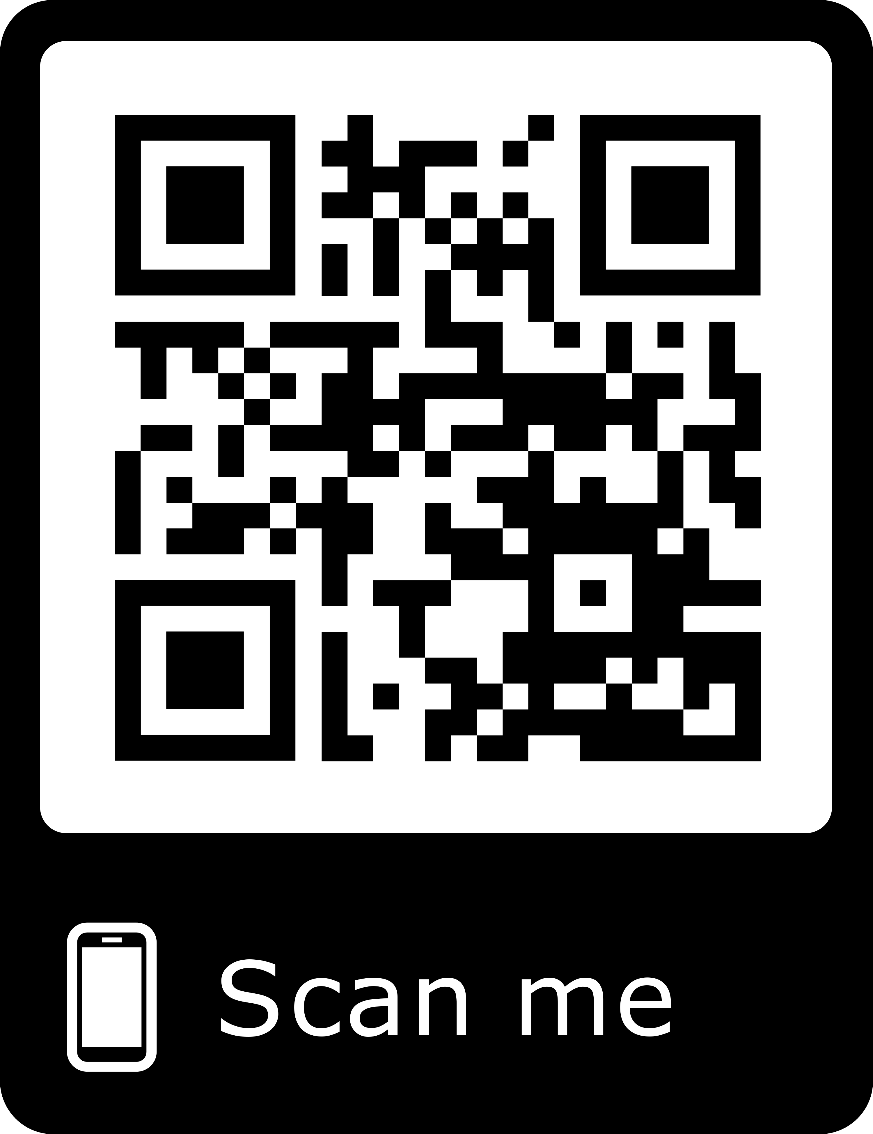
Ashi Anand Email : ashianand21@gmail.com
LInkedin : www.linkedin.com/in/ashi-anand-224374105/
Twitter : ashianand0607
Portfolio : ashi-06-jul.github.io

Academic Qualification :-

- Pursuing MCA from KIET Group of Institutions(AKTU).
- B.COM from Lucknow University 2017.
- Intermediate from ISC board in 2014.
- High School from ICSE board in 2012.

Professional Qualification :-

- A level from NIELIT in 2016.
- O Level from NIELIT in 2015.

Project Exposure:-

- Smart Belt and Headgear(Sep 2018 – Apr 2018) :-
It was an embedded system which helps blind people in obstacle detection and tells direction of obstacle by ticking on forehead.

- CIPA(Apr 2018 – Mar 2019) :-
IT is a website for an NGO who works for the parents whose child is suffering from a disease Cleft Lip and Palate. It was the first time when I interacted with so many doctors.
URL : http://cipa.co.in/

- MBA Conference(Dec 2018 – Feb 2019) :-
I with my team developed a website for MBA Conference in which I worked for MBA Department of my college.
URL : https://www.kiet.edu/conference_mba/

- DN College(Apr 2018 – Aug 2018) :-
I with my team developed a website for DN College, Meerut and the college is
using it.
URL : http://dncollege.net/

- WebGuru(Sep 2017 – Dec 2017):-
It was my first website development project in my first year.
URL : http://mca.kiet.edu/webguru/

Achievements :-

- Certificate of excellence in Testing Tool Selenium.
- Certificate of Merit in UNIX and Shell Programming.
- 1st Prize in category IOT in KARMANA 2K19.
- 1st Runner Up in FACE OFF in EPOQUE-2K18.
- 2nd Runner Up in FOOT LOOSE in EPOQUE-2K18.

Skills :-

- Programing Language : HTML & CSS
- Database
- Blockchain
- C Language

